Project Design Phase-II
Data Flow Diagram & User Stories
Date | 15 July 2026
Team ID
Project Name | UCab Premium – Cab Booking Application
Maximum Marks | 4 Marks

Data Flow Diagram – Level 0
The diagram below shows how data moves between Riders, Drivers, Admin, and UCab Premium's four core processes: booking & assignment, trip & fare processing, receipt/notification, and analytics & user management.
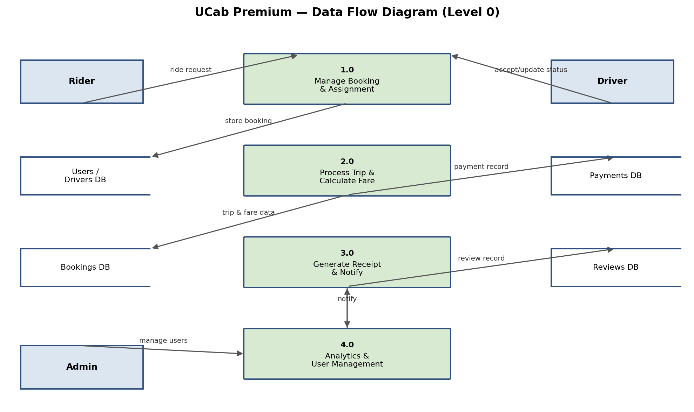
Figure 1: DFD Level 0 for UCab Premium

User Stories
User Type | Functional Requirement (Epic) | Story No. | User Story / Task | Priority | Release
Rider | Registration | USN-1 | As a rider, I can register by entering my email, password, and confirming my password. | High | Sprint-1
Rider | Registration | USN-2 | As a rider, I receive a confirmation email once I have registered. | High | Sprint-1
Rider | Login | USN-3 | As a rider, I can log in using my email and password to receive a JWT session. | High | Sprint-1
Rider | Booking | USN-4 | As a rider, I can request a ride by entering pickup and drop locations. | High | Sprint-1
Rider | Booking | USN-5 | As a rider, I can view the live status of my ride (Pending, Assigned, Accepted, On the Way, Completed). | High | Sprint-2
Rider | Payment | USN-6 | As a rider, I can view and download a PDF receipt after my trip is completed. | Medium | Sprint-2
Rider | Feedback | USN-7 | As a rider, I can rate and review my driver after trip completion. | Medium | Sprint-2
Driver | Registration | USN-8 | As a driver, I can register and submit my details for approval. | High | Sprint-1
Driver | Booking | USN-9 | As a driver, I can accept or reject an assigned ride request. | High | Sprint-2
Driver | Booking | USN-10 | As a driver, I can update the ride status as I progress through the trip. | High | Sprint-2
Admin | Dashboard | USN-11 | As an admin, I can view analytics on total rides, revenue, and user growth. | Medium | Sprint-3
Admin | Management | USN-12 | As an admin, I can view and manage all registered riders and drivers. | Medium | Sprint-3

